|  |  |  |
| --- | --- | --- |
|  | Available online at www.sciencedirect.com |  |
|  |
| AASRI Procedia 3 ( 2012 ) 501 – 507 |

2012 AASRI Conference on Modelling, Identification and Control

High-resolution Counting System based on DSP and CCD

Qi Xiao-guang,Sui Xiu-wu*,Li Da-peng

*Tianjin Key Laboratory of Advanced Mechatronics Equipment Technology, School of Mechanical Engineering,Tianjin Polytechnic University,*   
*Tianjin,China*

**Abstract**

This paper presents a high-resolution CCD counting system based on the Texas Instruments (TI) TMS320VC5509 Digital Signal Processor (DSP).The counting system is used in pharmaceutical packaging machinery. The major advantage of the system is high in counting speed , stable and reliable in performance. The counting system meets the requirements of speed and precision for pharmaceutical packaging machinery.

© 2012 Published by Elsevier B.V. © 2012 The Authors. Published by Elsevier B.V. Open access under [CC BY-NC-ND license.](http://creativecommons.org/licenses/by-nc-nd/3.0/)

Selection and/or peer review under responsibility of American Applied Science Research Institute

Key words:Counting System,TMS320VC5509,TCD1209D,EMP3064A;

**1.Introduction**

In order to meet the requirements of speed and precision for pharmaceutical packaging machinery, the counting system of electronic counting-machine is designed based on DSP and linear CCD sensors [1]. Compare with the old system, the system resolution is higher; counting speed is faster, filling accuracy is much higher. Meanwhile, the system can detect tablets size and adhesion, then picks out the medicine bottle filled with crushing-pills. The counting system makes electronic counting-machine is much more efficient.

*SUI Xiu-wu. Tel.: +1-392-035-1685.

*E-mail address:*allensui@163.com.

QI Xiao-guang.Tel.:+1-890-207-5875   
*E-mail address:*qixiaoguang629@163.com

2212-6716 © 2012 The Authors. Published by Elsevier B.V. Open access under [CC BY-NC-ND license.](http://creativecommons.org/licenses/by-nc-nd/3.0/) Selection and/or peer review under responsibility of American Applied Science Research Institute doi: 10.1016/j.aasri.2012.11.079

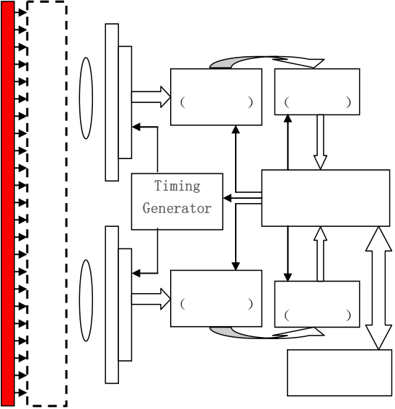

502  *Qi Xiao-guang et al. / AASRI Procedia 3 ( 2012 ) 501 – 507*

**2.Design of system**

Fig.1 shows the functional blocks in the Counting System. As is shown in Figure 1, through the lens, the light shoots at the CCD sensor, and immediately the sensor converts the light into electric charge and processes it into electronic signals. When pills fills down through the detection channel, the light intensity in the detection channel will be weakened, and then the electronic signals from the CCD sensor will be changed. The Light source provides the system with stable light intensity. Through the detecting space, the pills image on photo surface of CCD sensor. TLC2543 takes the analog signal , processed by the CCD sensor, conversion

|  |  |  |  |  |
| --- | --- | --- | --- | --- |
| for digital signal and the digital signal will be sent to the First In First Out |  | FIFO |  | memory for the frequency |

matching factor between the ADC(TLC5510) and DSP(TMS320VC5509).The ADC and the FIFO data-in operation are also driven by the timing generator.

|  |  |  |
| --- | --- | --- |
| **Light** | **Detection** | **CCD** |
| **Source** | **Channel** |

**Sensor**

ADC I FIFO I   
TLC5510 AL422B

**Lens**

MCU   
(TMS320VC5509A)

|  |  |
| --- | --- |
| ADC II  TLC5510 | FIFO I  AL422B |

Human Machine

Interface

Fig. 1.Block diagram of counting system

The TMS320VC5509 gets the commands from the HMI(Human Machine Interface), and it not only provides the timing signal to the ADC and FIFO, but also sets the counting mode of the system. In the meantime, the timing generator provide timing signal for CCD sensor. The DSP continually reads out the image data from the FIFO by the half-full flag of FIFO until all of the data from detection channel sent to the synchronous dynamic random access memory(SDRAM) by itself. After a series of data processing, the DSP send the processing results to the HMI. The touch screen (Human Machine Interface) show the results and save the results to SD card automatically.

**3.Optical system**

However, on order to improve the system reliability, a reliable optical system is the key factors. In this step, the system coverts light into electronic.

*3.1.Design of Optical circuit*

The Toshiba TCD1209D is used as a sensor of the counting system. The device contains a row of 2048 elements photodiodes, and the Image Sensing Element Size is 14m [2]. The Imaging length is:

|  |  |  |  |  |  |  |
| --- | --- | --- | --- | --- | --- | --- |
| *L* | 2048 |  | .0 014 | 28.672 | *Qi Xiao-guang et al. / AASRI Procedia 3 ( 2012 ) 501 – 507* | 503 |
| *mm* | *(1)* |

As is shown in Fig. 2, the detection distance is 400mm.So the counting system will be divided into two parts of CCD, and a single CCD optical circuit schematic diagram is shown in Fig.2.

Work Distance Back focal plane Distance

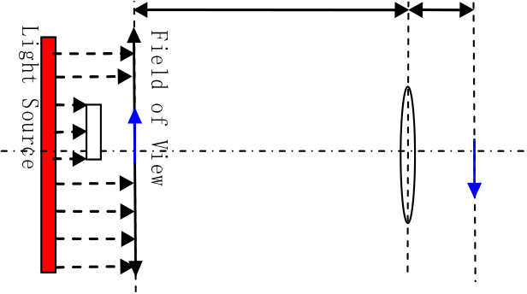

Fig. 2.Single CCD optical circuit schematic diagram

The magnification of the single CCD optical circuit is defined as *MD*[3].

|  |  |
| --- | --- |
|  | *(2)* |

In equation 2, the letters are defined as follows,u: the object distance or the work distance(WD); v: the image distance; L: the imaging length; FOV: the field of view;   
If the image distance is 18mm, working distance:

|  |  |  |  |  |  |
| --- | --- | --- | --- | --- | --- |
| *WD* | *u* | *v* | 18 | 125 .35mm | *(3)* |
|  |  | *M* | 0.1436 |  |  |

As is shown in type (4), the focal length can be calculated:

|  |  |  |  |  |  |  |  |  |  |  |  |
| --- | --- | --- | --- | --- | --- | --- | --- | --- | --- | --- | --- |
| *F* |  |  | *WD* |  |  | 125 | .35 |  | 15 .7 | *mm* | *(4)* |
|  | ( | 1 | 1  ) *MD* | ( | 1 | 1    0 .1436 | | ) |  |  |  |

In equation 4, the letters are defined as follows, *F*: the focal length;*WD*: the work distance;*MD*: the magnification;   
According to results of the equation 4, the focal length is 16mm.

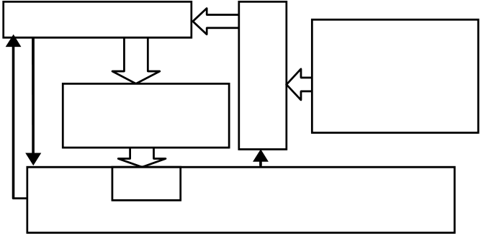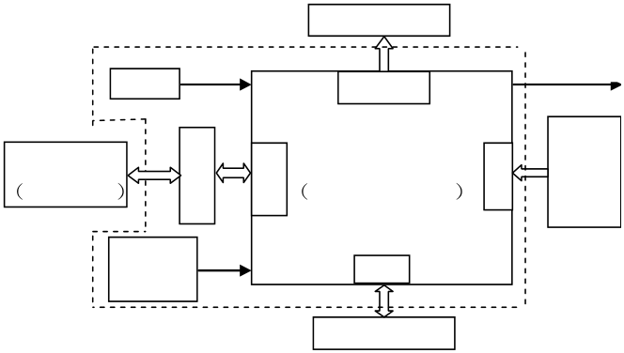

504  *Qi Xiao-guang et al. / AASRI Procedia 3 ( 2012 ) 501 – 507*

*3.2.Timing Generator*

|  |  |
| --- | --- |
|  | **AL422B**   **Imaging**  **Interface**   **Circuit**   EMIF   TMS320VC5509A |

Fig. 3(a)Output sequence of timing generator ;(b)Block diagram of the data acquisition

The Altera EMP3064A is used as the timing generator of the counting system. EMP3064A is a CPLD chip

|  |  |  |  |  |
| --- | --- | --- | --- | --- |
| with 64 micro-cells, 1250 usable gates and 66 user I/O pins.Line timing(SH),driving timing( |  | 1and |  | 2), reset |

pulse timing(RS), buffering timing(CP) are all generated by the EMP3064A chip, furthermore, EMP3064A receive the synchronous signal from DSP[5][6]. The output sequence of timing Generator is shown in Fig.3(a).

**4.Data acquisition**

The CCD sensor converts the light into electric charge and processes it into analog signal. However the analog signal must be transformed into the digital signal so that it can be recognized and used by DSP. The Texas Instruments (TI) TLC5510 is used as the ADC. The TLC5510 is CMOS.8-bit, 20 MSPS analog-to-digital converters that utilize a semi-flash architecture [4].ALL422B is used as the FIFO, that consists of 3M-bits of DRAM, and is configured as 393,216 words. The signals were stored and then transmitted to RAM of DSP. The ADC and FIFO receive synchronous sequential signal which come from DSP. The block diagram of Data acquisition is shown in Fig.3(b)

**5.Data Processing**

The Texas Instruments (TI) TMS320VC5509A is used as MCU. The TMS320VC5509A of fixed-point digital signal processor (DSP) is based on the TMS320C55x DSP generation CPU processor core. With performance of 8000 million instructions per second (MIPS) at a clock rate of 200MHz, the C55x devices offer cost-effective solutions to high-performance DSP programming challenges. The block diagram of DSP module is shown in Fig.4(a)

**Jolting Table**

|  |  |  |  |  |
| --- | --- | --- | --- | --- |
| **Crystal** | TIMER1 | **SYNC** | **Scanning** | **Drop Pills** |
| **HMI** | DSP |
| MT506TV | TMS320VC5509 |
| **Power** | GPIO | **line** |
| **Supply** |
| **Drive Circuit** |

Fig.4(a)Block deagram of DSP module;(b) CCD detection schematic diagram

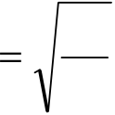

*Qi Xiao-guang et al. / AASRI Procedia 3 ( 2012 ) 501 – 507*  505

As is shown in Fig.4(b), the DSP module determines the integrity of the pills, through the judgment x and y sizes.

From the edge of the jolting table dropped the pills at same speed of horizontal velocity. Through the type 5

|  |  |  |  |  |  |  |  |  |  |  |
| --- | --- | --- | --- | --- | --- | --- | --- | --- | --- | --- |
| and 6,when the pill down to detection channel, the speed( | | | | | | |  | ) and time ( t ) can be calculated. | | *(5)* |
| *t* | | | | | | | 2 | *h* |
| *g* | |
| *v* | | | | | | | *gt* | | *(6)* |
| The calculated results is: | *t* | .0143 *s* |  | *v* | 4.1 | *m s* |

As is shown in Fig. 4(b), the time which one of diameter 9 mm thickness of 4.5 mm pills goes through the detection channel is defined as t1. The falling height is defined as. The equation 7 indicate the relationship

of t1 and.

1

*gt* 12*vt* 1  *(7)*  2

The solutions of equation 7 is:t1=6.4ms.

The scanning time which is the CCD sensor scans 2048-pixels is defined as t0.

|  |  |  |  |  |  |  |  |  |
| --- | --- | --- | --- | --- | --- | --- | --- | --- |
| 0t =2048 | |  | 1/10MHz=2.048 | | | |  | 10 s *(8)* |
| From above we can know, when the pill goes though the detection channel, it will be scanned ' *n* times and  the ' *n* is: | | | | | | | | |
| *n* | ' | | | *t* | 1 | 3 1 | *(9)* | |
| *t* | 0 |  | |

As is shown in Fig. 5, the pulse width tells the x-size (use as "x" ).

|  |  |  |
| --- | --- | --- |
| *x* | *B* 0.014 |  |
|  | *M* | *(10)* |

In equation 10, the variables are defined as follows:   
*B*: the pulse width; *M:* the magnification

506  *Qi Xiao-guang et al. / AASRI Procedia 3 ( 2012 ) 501 – 507*

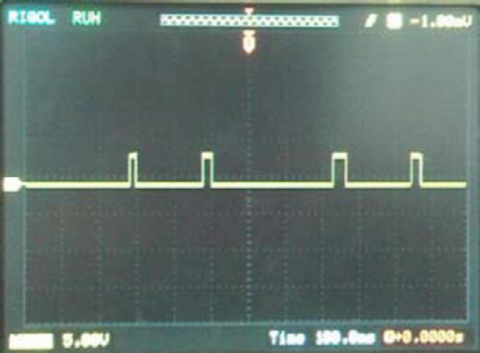

Figure.5. CCD output signal

The y-size(use as "y") can be told by the number of CCD sensor scanning. y is the calculation of equation 11.

|  |  |  |  |  |  |  |  |  |  |  |  |
| --- | --- | --- | --- | --- | --- | --- | --- | --- | --- | --- | --- |
| *y* | 1 [( ' 1) ] 0 2  2 | | | | |  | *v n* ( '1) *t* | | | 0 | *(11)* |
| In equation 11, the variables are defined as follows. | | *n :* scanning time, *t0:* the line scanning time of CCD | | | | | | | | | |
| sensor, *g:*  the gravitational acceleration*,* g*=9.8m/s2* | |  | *:* | *v* | 1. 4 | *m* | | / | *s* | | |

The DSP judges whether the pill is fracture or not,and marks the bottle through comparing x, y and data coming from HMI.

**6.Human Machine Interface**

The Weinview MT506TV is used as a Human machine interface(HMI) of the counting system. The interface of man-machine communication based on the Modbus protocol .The design of interface is shown in Fig.6.

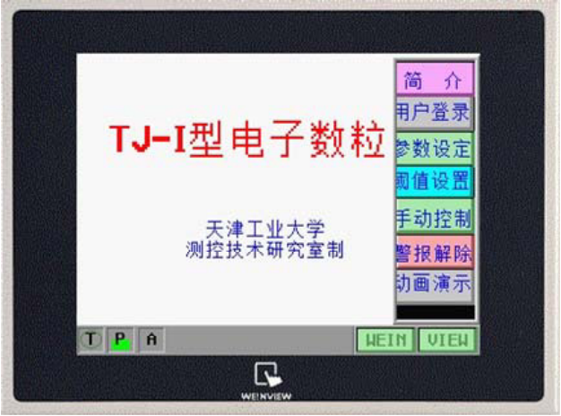

Fig.6. Design of HMI

**7.Conclusion**

The counting system is installed in the electronic counting-machine, which runs to 48 hours long, its counting speed up to 10000~12000 tablets per minute. The system error can be dropped below 4.67%. The counting system can meet the demands in practice.

Experiments show that the system is high in counting speed, stable and reliable in performance.



*Qi Xiao-guang et al. / AASRI Procedia 3 ( 2012 ) 501 – 507*  507

**Acknowledgements**

We would like to express our gratitude to Mr.Wang.With his help,we are possible to get much information about the CCDs and enough funds to perform the experiment.

**References**

[1]Lian Lu, The present situation of American packaging industry and the difference in china, Chinese

|  |  |  |  |
| --- | --- | --- | --- |
| Packaging Engineering, 2005 | 26(3) |  | 15 -- 16 |



[2] TOSHIBA Corp. TCD1209D datasheet[S]. 1999   
[3]Wang Qingyou, The technology of the CCD application [M], Tianjin: Tianjin university Press, 2000 [4]TLC5510,TLC5510A 8-BIT HIGH-SPEED ANALOG-TO-DIGITAL CONVERTERS,   
Texas Instruments,Inc.,MAY.1999.

[5]Dou Jianhua, Wang Ying, Li Changkai, et al, Design of linear array CCD data acquisition system based on CPLD and DSP, Journal of Hefei University of Technology, 2010 33(5):690-693

[6]Xiang Dapeng, YangJiang Yang Jian, Design of Driving Time Sequence Circuit of Linear Array CCD

Based on CPLD, Journal of Geodesy and Geodynamics, 2010,30 2 123-125.